Balancing Chemical Equations

1. Get yourself an unbalanced equation. 2. Draw boxes around all the chemical formulas. Never, ever, change anything inside the boxes. Ever. Really. If you do, you're guaranteed to get the answer wrong.

3. Make an element inventory.

4. Write numbers in front of each of the boxes until the inventory for each element is the same both before and after the reaction. Whenever you change a number, make sure to update the inventory - otherwise, you run the risk of balancing it incorrectly.

**An example of equation balancing:**

1. **Get yourself an unbalanced equation.**

These are simply the formulas for the chemicals named in the problem

**2. Draw boxes around all the chemical formulas.** . You're drawing those boxes so that you'll be sure not to mess around with the formulas to balance the equation. Here's what the equation looks like:

All I did was put boxes around the formulas.

**3. Make an element inventory.** In this inventory, your job is to figure out how many atoms of each element you have on the left and right sides of the equation. Your element inventory should look like this:

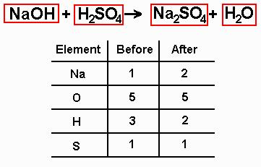

**4. Write numbers in front of each of the boxes until the inventory for each element is the same both before and after the reaction.** Now, what happens when we put a number in front of a formula? Basically, anything in that box is multiplied by that number, because we're saying that we have that many of that kind of molecule.

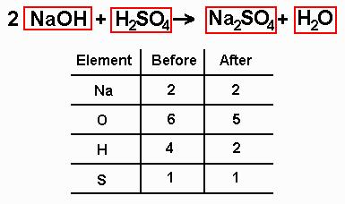

 Now what? Well, looking at the new inventory, we can see that we now have two sodium atoms on both the left and the right sides, but the others still don't match up. You can see from the inventory that on the right side of the equation, there are two hydrogen atoms and on the left there are four. Put a "**2**" in front of the water on the right side of the equation to make the hydrogens balance out. Now that this is done, you should make a new inventory that looks something like this:

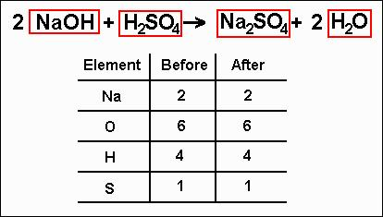

Since both sides of the inventory match, the equation is now balanced!